Sennheiser esittelee Scenicon ja Polifonian – uutta potkua autojen immersiiviseen tilaääneen ja personoituun kuuntelukokemukseen
Uudet teknologiat tarjoavat immersiivisiä äänentoistoratkaisuja, jokaiselle matkustajalle räätälöidyn kuuntelukokemuksen sekä entistä laajemmat vapaudet ajoneuvon sisätilojen arkkitehtuurille ja muotoilulle.
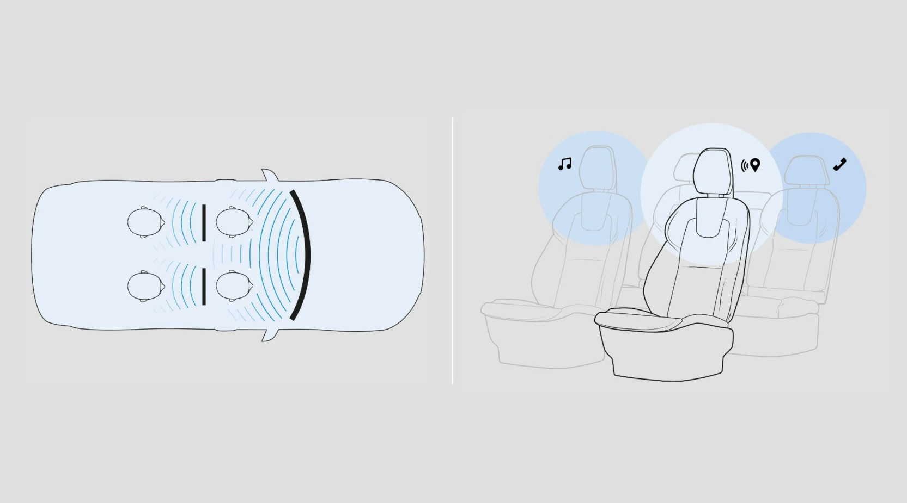

Sennheiser laajentaa autoäänentoiston rajoja esittelemällä AMBEO-teknologiaa hyödyntävän Scenicon sekä Polifonian. Nämä kaksi ääniteknologista innovaatiota määrittelevät uudelleen tavan, jolla kuljettajat ja matkustajat kokevat huippuluokan äänentoiston tien päällä. Sennheiser Mobility -yksikön autoäänen asiantuntijoiden kehittämät teknologiat ilmentävät yhtiön määrätietoista panostusta korkealaatuisten ja älykkäiden äänielämysten kehittämiseen, mikä parantaa matkustamon mukavuutta, turvallisuutta ja viihtyvyyttä.
Lisää alla englanniksi.

Scenico with AMBEO Technology is Sennheiser’s patented loudspeaker array software module designed to deliver compact immersive sound through transducers integrated into the dashboard. By concentrating loudspeakers in a single compact zone, Scenico reduces hardware placement complexity and provides automotive designers with greater flexibility when developing vehicle interiors. The approach can also enable the removal of loudspeakers from vehicle doors, supporting easier disassembly and recycling, as well as supporting off-road vehicle use with improved wading depth.

Despite its reduced speaker footprint, Scenico creates a soundstage that extends well beyond the physical boundaries of the vehicle while delivering a remarkably stable center image. While suitable for any vehicle size, Scenico is ideal for medium-size cars that demand high-quality immersive audio while placing a premium on space and design restrictions. When used in the second row of larger vehicles, Scenico can also enable best-in-class immersive rear-seat entertainment.

Polifonia is Sennheiser’s novel audio processing software module that enhances acoustic separation between seating positions with the assistance of noise cancellation technology. By canceling acoustic interference between seats with the use of headrest speakers, Polifonia enables personalized listening experiences for each occupant, allowing the driver to receive navigation guidance, safety alerts, or other relevant information without disturbing passengers. At the same time, passengers can enjoy their own entertainment content without distracting the driver.

"The future of automotive audio is about delivering richer experiences while intelligently adapting to the needs of every occupant," said Dr. Véronique Larcher, Managing Director of Sennheiser Mobility. "With Scenico and Polifonia, we are advancing the state of the art in both immersive sound reproduction and personalized audio delivery. Scenico demonstrates how our innovative loudspeaker array technology can create a remarkably wide and stable soundstage while giving automakers greater freedom in vehicle design. Polifonia takes personalization to the next level by enabling occupants to hear different content simultaneously. The driver can focus on navigation guidance and safety-critical information, while passengers enjoy music, movies, or gaming audio tailored to their own preferences. Together, these innovations bring us closer to a future where every seat in the vehicle can become its own premium listening space."

With Scenico and Polifonia, Sennheiser continues to push the boundaries of automotive audio technology, helping manufacturers create smarter, more immersive, and more sustainable in-car experiences for the next generation of vehicles.

For more information about Scenico with AMBEO Technology or Polifonia, or to schedule a demo, please contact the Sennheiser Mobility team at mobility@sennheiser.com.

(Ends)

About Sennheiser
We live and breathe audio. We are driven by the passion to create audio solutions that make a difference. This passion has taken us from the world’s greatest stages to the quietest listening rooms – and made Sennheiser the name behind audio that doesn’t just sound good: It feels true. Since 1945, we have stood for building the future of audio and bringing remarkable sound experiences to our customers. While professional audio solutions such as microphones, meeting solutions, streaming technologies, professional headphones, automotive audio solutions, as well as wireless microphone and monitoring systems are part of the business of Sennheiser electronic SE & Co. KG, the business with consumer devices such as headphones, soundbars and speech-enhanced hearables is operated by Sonova Holding AG under the license of Sennheiser.
www.sennheiser.com
www.sennheiser-hearing.com

Press Contact
Burson Finland Oy
sennheiser.finland@bursonglobal.com

